1. Revising the Select Query I

=======================

Query all columns for all American cities in the CITY table with populations larger than 100000. The CountryCode for America is USA.

The CITY table is described as follows:

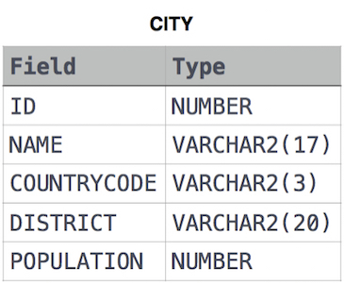

Answer:

======

select \*

from CITY

where POPULATION > 100000 and COUNTRYCODE = 'USA'